

DIPLOMA IN COMPUTER SCIENCE SCHOOL OF COMPUTING

Assessment: Individual Assignment

Course Code: | DCS3003
Course Name: | WEBSITE DESIGN
Academic Session: | September - December 2025
Lecturer’s Name: | Ms Teo Choon Yeh

Release Date: | 19th September 2025
Submission Due Date: | 2nd November 2025


Weightage

)
%
(
:

15

Marks

Obtained
:

15

Student’s Declaration
I certify that this assignment is my own work, and appropriately acknowledged wherever material adapted from other sources. I understand that plagiarism, cheating, collusion, fraud, fabrication or falsifications of data are not acceptable. I agree that if at any time it is shown that I have significantly misrepresented material submitted to Crescendo International College, any marks or credits awarded to me on the basis of that material may be revoked.

Student Name | ANLI HO HUI TING | Student ID | DCS2509227
Signature |  | Date | 3/11/2025

GithubLink: https://anlilolfunpng.github.io/MyWebsite/Individual%20Assignment/Homepage
https://anlilolfun-png.github.io/MyWebsite/Individual%20Assignment/style11.css
Contents
Introduction 4
Responsive vs. Adaptive Web Design 5
Responsive Web Design 6
The Cons of Responsive Design 6
Example of Responsive Design 7
Adaptive Web Design 8
The Pros of Adaptive Design 8
The Cons of Adaptive Design 8
Example of Adaptive Design 8
Which is better? 9
Conclusion 10
Sitemap for Project Website 11
Explanation of the Sitemap Structure 13
References List 14

Introduction
In today's online world, a well-designed website is vital for any business.
This assignment will create a responsive homepage that looks great and works well on desktops, tablets, and mobile devices.
By exploring responsive and adaptive design, it aims to improve user experience while ensuring everything functions smoothly.
Thus, the goal is to build an interactive website that meets the needs of users and keeps them engaged.

[68words]
Figure 1Introduction Website design
Responsive vs. Adaptive Web Design
In earlier times, web designers designed the user interface of the website by considering the size of the desktop. but nowadays we use websites for Mobile, Tablet, laptops, Wearable devices, and many more devices, so the size of the screen differs for each device. So Responsive Design and Adaptive Design come into play: responsive design and adaptive design. Both provide a better user interface for all types of devices, but both follow different needs.

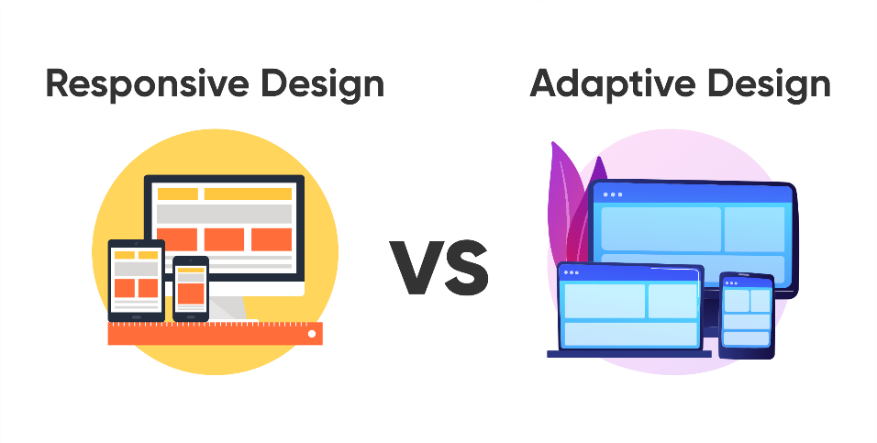
[79words]
Figure 2Diffrences between responsive and adaptive design

Responsive Web Design
Responsive web design is all about flexibility. Imagine a website that adjusts its layout and content seamlessly, no matter what device you’re using—be it a smartphone, tablet, or desktop. It uses fluid grids and CSS media queries to ensure that everything resizes and rearranges automatically based on the screen size.

The Pros of Responsive Design
First and foremost, since the site adjusts to fit different screens, you only need to maintain a single URL. This is great for SEO because all traffic goes to the same place.
Therefore, Users can enjoy a consistent experience, whether they’re on their phone or their laptop. The content remains accessible and visually appealing.
Lastly, as new devices come out with different screen sizes, a responsive design can allow websites to remain relevant and functional.

The Cons of Responsive Design
Firstly, if a site is not optimized well, it can be slower on mobile devices because they often load all content, even if some of it isn’t needed for smaller screens. Nobody likes waiting for a slow page to load!
Designing for multiple screen sizes can be challenging, requiring careful planning and testing to ensure everything looks good on all devices.
Responsive design may limit the ability to customize layouts for specific devices, which can be a drawback for some designers.

Example of Responsive Design
Amazon
Amazon's website adapts to various screen sizes using responsive design principles. Whether you’re shopping on a smartphone, tablet, or desktop, the layout and features rearrange to give you a smooth and consistent shopping experience. It’s all about making it easy for you to find what you need, no matter where you are!
Bootstrap
Bootstrap is a popular front-end framework that allows developers to create responsive websites quickly. It uses a fluid grid layout that adjusts to the screen size, making it suitable for mobile devices, tablets, and desktops.

[312words]

Adaptive Web Design
Adaptive web design takes a more tailored approach. It involves creating multiple fixed layouts for specific screen sizes. When a user accesses the site, it detects the device and loads the appropriate layout.

The Pros of Adaptive Design
Adaptive Design gives many advantages to people:
Firstly, adaptive design allows for a unique experience on each device, optimizing interactions and layout for specific screen sizes, which can enhance user satisfaction.
Furthermore, Since adaptive sites load different layouts based on the device, they can be more efficient in terms of loading only what’s necessary for that specific screen size.
Moreover, designers have more control over how the site looks on different devices, allowing for a more deliberate approach to user experience.

The Cons of Adaptive Design
Adaptive Design gives many disadvantages to people:
Firstly, Adaptive design often requires different URLs for different layouts, which can complicate SEO and sharing.
Then, managing multiple layouts means more code, leading to increased complexity and potential for errors.
Last but not least, creating designs for various devices can be time-consuming and require more resources.

Example of Adaptive Design
Facebook
Facebook uses adaptive design to serve different layouts based on the device being used. For example, the mobile app and mobile website have distinct designs optimized specifically for smaller screens.
Wikipedia
Wikipedia employs adaptive design principles, offering different layouts for desktop and mobile users. It serves a simplified version on mobile devices while maintaining a more complex structure for desktops.

[246words]

Which is better?
So, which one should you choose? It depends on your goals. If you want simplicity and ease of maintenance, responsive design is the way to go. However, if you’re looking to provide a very specific experience for different devices and have the resources to create multiple layouts, adaptive design might be the better option.
In the end, both are aim to enhance user experience, but they go about it in different ways. Using these tools will help you make informed decisions when designing your website.

[88words]

Conclusion
In conclusion, the differences between responsive and adaptive website design is essential for creating effective websites in today’s diverse digital ecosystem. Responsive design offers a fluid approach, where a single layout adjusts gracefully to any screen size. This ensures that users—whether on a smartphone, tablet, or desktop—enjoy a consistent and cohesive experience, much like a well-fitted outfit that adapts to various occasions.
In contrast, adaptive designs are a more tailored method, serving distinct layouts for specific devices. This allows designers to craft unique experiences that cater to the capabilities of each device, similar to how a custom menu might highlight different dishes based on the time of day or customer preferences.
Hence, the choice between responsive and adaptive design should be guided by the needs of the project and its audience. Keep in mind that the goal is to create a website that not only meets technical requirements but also resonates with users, making their journey through digital space enjoyable and meaningful. Thus, this opportunity to showcase creativity and design skills!
[172words]

Sitemap for Project Website
Creating a sitemap is an essential step in organizing the website’s structure. It helps visualize how different pages relate to each other and how users will navigate through the site. Here's a simple sitemap for my project website:
[42words]
About Us
Q&A
Contact Us
Student Programmes
Student Services
Title
Logo
picture
picture
Footer
Home Page

Explanation of the Sitemap Structure
Firstly, the home page is the starting point of the website. It gives visitors a friendly introduction to what the assignment is about, setting the stage for a deeper dive into the content. This home page includes the overview and the News and Announcements.
Secondly, this is the section that contains information about the organization behind the website. It usually includes the mission, vision, and values, helping users understand the purpose and goals of the organization. Thus, there is a timeline of history.
Thirdly, users can find detailed information about various programs offered in student programmes. This could include descriptions of different courses, their benefits, and how they fit into the overall offerings of the institution.
Next, this section addresses the questions asked. It provides answers to common queries that users might have, making it easier for them to find information without direct assistance.
Moreover, users can also find the student organization, such as a directory of clubs and organizations, including how to join. Thus, there are some housing options that will show the on-campus and off-campus living arrangements. Hence, there is an events calendar that lists out the upcoming events, activities, and important dates.
Furthermore, Contact Us is the section where users can find ways to get in touch with the organization. It often includes contact details such as phone numbers, email addresses, and a form for inquiries or support.
Last but not least, the footer contains additional links to important information such as privacy policies, terms of service, or social media links. It may also include copyright information related to the website.

[269words]

Figure 3Explanation Sitemap Structure

Campus life
Contact Us
Student Programmes
Home Page
Student Services
About Us

References List

Medium
(https://medium.com/theymakedesign/responsive-vs-adaptive-web-design-1da9e5398669)
BrowserStack
(https://www.browserstack.com/guide/adaptive-design-vs-responsive-design)
The Interaction Design Foundation
(https://www.interaction-design.org/literature/topics/adaptive-design?srsltid=AfmBOoqfYoVGont9Ycqfirmpq9hGf3UEy5kpz95lNriO2z9hcALDtYc_)

